In Memory Of

Oren Eugene Sanders

BORN
March 23, 2016, Couch, Missouri

DIED
March 24, 2016, West Plains, Missouri

SERVICE
Monday, March 28, 2016 – 1:00 p.m.
Carter Funeral Home Chapel
West Plains, Missouri

OFFICIANT
Reverend David Ball

READING OF THE OBIT
Charles Phelps

SOLOIST/PIANIST
David Ball
ACTIVE PALLBEARERS
Kenny Collins Gary Gordon
Steve Greer Robert Harris
Charles Phelps Junior Stewart
HONORARY PALLBEARERS
Emmaus Road Sunday School Class

INTERMENT
Oak Lawn Cemetery
West Plains, Missouri
FUNERAL DIRECTORS
Carter Funeral Home, Inc., West Plains, Missouri

Oren Eugene Sanders, 92, of West Plains, Missouri passed away on March 24, 2016 at Ozarks Medical Center in West Plains.
Mr. Sanders was born March 23, 1924 at Couch, Missouri, to Vertie Russell Sanders and Robert Jackson Sanders, Sr.
He attended school at the Garﬁeld School and graduated with the Class of 1942 at Couch High School, both in Oregon County. After graduating from high school, he trained as a machinist and worked on his family's farm until he was inducted into the United States Army in 1943 proudly serving during World War II as a machinist. He liked to tell that during his military service he traveled around the world leaving New York City for France then Germany. He sailed through the Panama Canal
on his way to the Philippines, then to Japan, and returning to the states at Seattle, Washington.
Oren Sanders married Ada Jessilee Stubbleﬁeld on September 21, 1946. They were to have celebrated 70 years of marriage this year.
Their two children are Edward E. Sanders and Donna Sanders Hayes.
Mr. Sanders and his brother-in-law, Joe Stubbleﬁeld, owned and operated Sanders and Stubbleﬁeld Implement Company in Alton and West Plains from 1957 until he sold his interest in 1972. He was a proud JOHN DEERE man; his favorite tractor was his 1941 John Deere LA which he drove in many local parades. He was a charter member of the Early Days Gas Engine/Older Iron Club and was

inducted into that organization's National Hall of Fame.
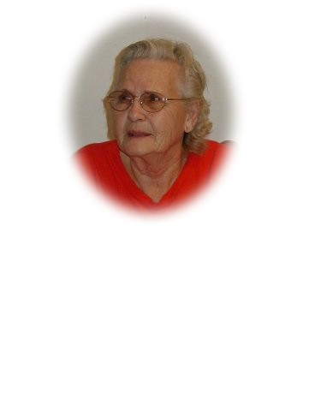
Oren and Jessie were active in the Veterans of Foreign Wars Post 1828. He was past president and also served on the Veterans Honor Guard presiding over dozens of military funerals. He had attended First Baptist Church of West Plains since 1964.
Mr. Sanders is survived by his wife, Jessie, West Plains; son Edward, Memphis, Tennessee; daughter Donna and her husband Mike Hayes, West Plains; grandsons Brian Sanders and wife Amanda of Ft. Worth, Texas, and Mark Sanders of Wichita, Kansas; and great grandchildren
Brittany and Ross Sanders of Ft. Worth. He is also survived by step-grandchildren Andrew, Elizabeth, Taylor and Haydn; sisters-in-law Frances Sanders and Wilda Stubbleﬁeld; two nieces and two nephews.
He is preceded in death by his parents Vertie Sanders and Robert Sanders, Sr. and his step-mother Minnie Sanders; two brothers Carl Sanders and Robert Sanders, Jr.; sister-in-law Vesta Sanders and brother-in-law Joe Stubbleﬁeld. Also preceding him are his mother and father-in-law Albert and Myrtle Stubbleﬁeld, daughter-in-law Barbara Heinz Sanders, and one niece.

MILITARY RITES WILL BE PEFORMED
BY THE WEST PLAINS HONOR GUARD
AND THE
MISSOURI FUNERAL HONORS REQUEST TEAM

In Memory Of

Alta Heilig
1928 - 2016

